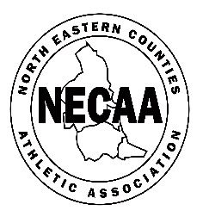

NORTH EASTERN COUNTIES ATHLETIC ASSOCIATION
YOUNG ATHLETES` CROSS COUNTRY RELAYS cc2022/0314
THORNLEY HALL FARM, PETERLEE, DH6 3LY

APRIL 2nd 2022

10.00 U13 GIRLS 3 x 3k 11 on the day or 12 on 31st August 2021

10.55 U13 BOYS 3 x 3k 11 on the day or 12 on 31st August 2021

11.45 U15 GIRLS 3 x 3k 13 and 14 years on 31st August 2021

12.35 U15 BOYS 3 x 3k 13 and 14 years on 31st August 2021

13.25 U17 MEN 3 x 3k 15 and 16 years on 31st August 2021

14.00 U17/20 WOMEN 3 x 3k U17 15/16 years on 31st August 2021
(NB maybe 13.30) U20 17/18/19 on 31st August2021

CONDITIONS OF ENTRY – Members of NECAA clubs (EA affiliated), with 9- month residence qualification and/or NE Counties birth qualification. All entrants must be first claim members (G2 S6)

ENTRIES £15.40 per team. ENTRIES CLOSE WEDNESDAY MARCH 23rd. https://northeastmastersathletics.weebly.com/necaa.html Entries open FEBRUARY 1

DECLARATIONS online before 7pm on Thursday March 31st. Alterations can be made up to 30 minutes before start times

CLUBS MAY ENTER A and B AGE GROUP TEAMS. NO REFUNDS

Please leave the venue after each race to assist with CAR PARKING

CLUB COLOURS must be worn (T5 S 1.3)

NECAA Championship medals will be awarded (one set of medals per club in each category) – last leg runners will collect the medals

RESULTS – NECAA website and Facebook
ENQUIRIES – NECAA Cross Country Secretary - Archie Jenkins archiemeadowriggs@btinternet.com. ENTRIES - Val Baxter masterstracksec@gmail.com

