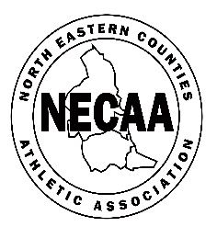

NORTH EASTERN COUNTIES ATHLETIC ASSOCIATION

SENIOR & MASTERS CROSS COUNTRY RELAYS cc2022/0313 THORNLEY HALL FARM, PETERLEE, DH6 3LY

MARCH 19th 2022

11.00 MASTERS WOMEN 40+ 3 x 3k

11.50 MASTERS MEN 40+ 3 x 3k

12.40 SENIOR WOMEN 3 x 3k

13.30 SENIOR/U20 MEN (3x3k) 4 x 3k

CONDITIONS OF ENTRY – The Championships are open to members of NECAA clubs affiliated to England Athletics who meet one of the following criteria: 9- month residential qualification and/or have NE Counties birth qualification. All entrants must be first claim members (G2 S6)

ENTRIES £15.40 per team (SM £20.60). ENTRIES CLOSE WEDNEDAY MARCH 9
https://northeastmastersathletics.weebly.com/necaa.html Entries open FEBRUARY 1

DECLARATIONS ONLINE BEFORE 7pm Thursday March 17th. Alterations no later than 30 minutes before the start of each race

CLUBS MAY ENTER A and B TEAMS in each category. NO REFUNDS WILL BE GIVEN. Please leave the venue after each race to assist with CAR PARKING

RUNNERS CAN RUN IN ONE CATEGORY ONLY and ONLY ONE LEG

CLUB COLOURS MUST BE WORN T5 S 1.3

NECAA CHAMPIONSHIP MEDALS WILL BE AWARDED (one set of medals per club in each category) – last leg runners will collect the medals.

RESULTS – NECAA and NEMAA Websites and Facebook
ENQUIRIES – NECAA Cross Country Secretary Archie Jenkins archiemeadowriggs@btinternet.com ENTRY ENQUIRIES – Val Baxter masterstracksec@gmail.com

