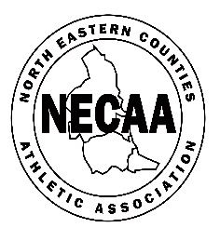

NECAA CROSS COUNTRY CHAMPIONSHIPS, SEDGEFIELD, Dec 11 2021
OUTSTANDING TROPHIES TO BE RETURNED ASAP
U13 Boys Team John Smith Trophy Theo Dragoi Gateshead H
U15 Boys Individual 2005 Shield Lyndsey Perkins Birtley AC
U15 Girls Team Trophy Hannah Johnston Alnwick H
U20 Women`s Individual Trophy L-E Hunter Darlington H
U17/20 Women`s Team Trophy Gateshead H
Overall Men Gallery Jewellers Trophy Morpeth H
Overall Women J C Kennedy Trophy Not seen since 2018
Misplaced by Gateshead H
Overall M`boro & C`land H Centenary Trophy Morpeth H

OUTSTANDING MEDALS TO BE COLLECTED
Senior Men`s Team 2nd and 3rd – Gateshead H and Tyne Bridge
Senior Women`s Team 2nd and 3rd – Morpeth H and Elswick H
U13 Girls Team 2nd NSP
U20 Men`s Team 2nd Durham City H
U17 Men`s Team 2nd Gateshead H

Medals collected and trophies returned Jan 8 NEHL Thornley between 11.00-11.30
(+ Trophies returned Saltwell 10k Dec 18)

